Petrit Krasniqi T00192719

JaVA CA

Table of Contents

Introduction 2

Class Diagram 3

VOPC Diagram 4

# Introduction

# Class Diagram

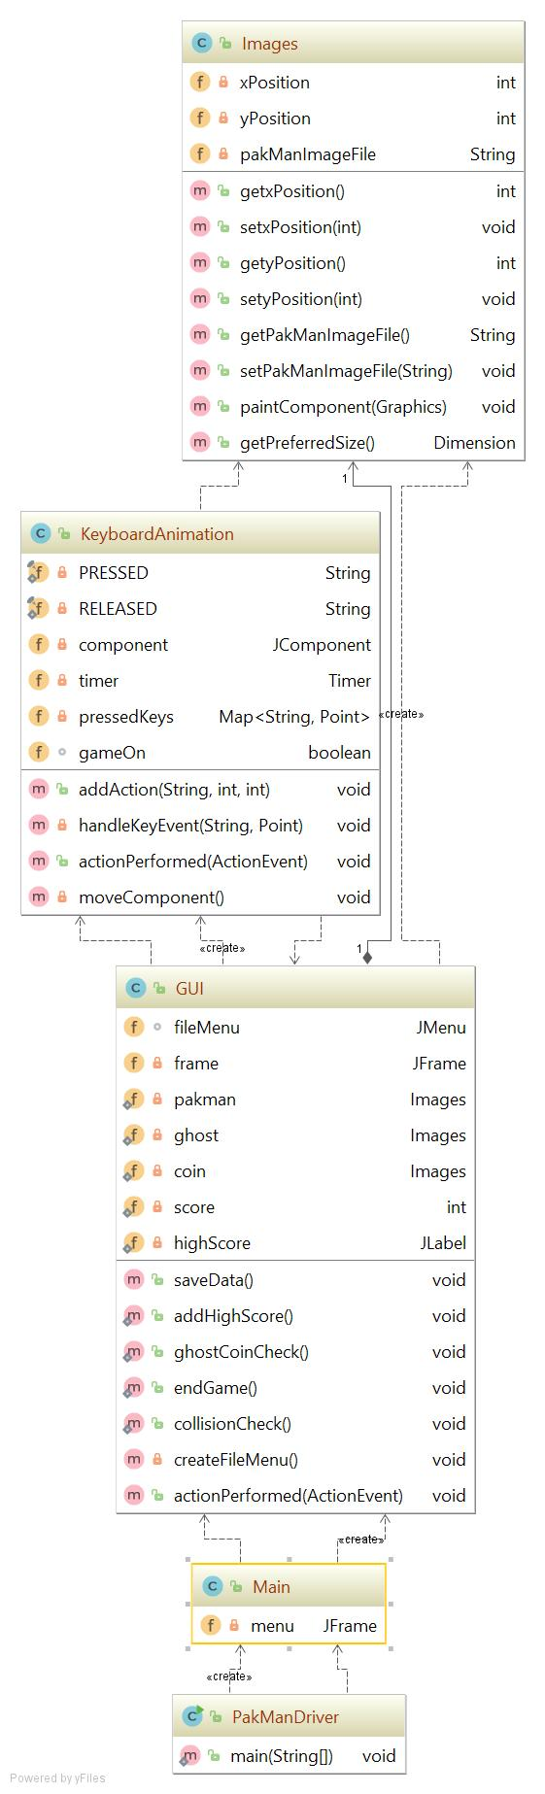

# VOPC Diagram

